Changed some single quotes to double quotes – line 9, 11, & 16

Needed to change Count to count and add a $

Didn’t create the sql file in lab environment like the instructions says. Also needed to change the file name within the script as it was pointing to the dummy one by the course instructor

Need to delete the OU and DB

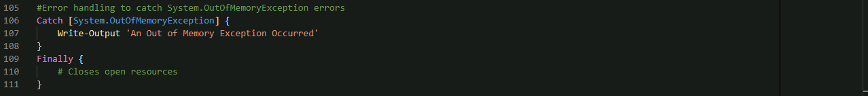

What table does the CreateTable_CustomerLeads.sql create? Is it CustomerLeads? The table should be called Client_A_Contacts

May need to change the command to

Invoke-Sqlcmd -ServerInstance $sqlServerInstanceName -Database ClientDB -Query

**FINAL SCRIPT**

